Basic Instructions for running the code in the directory.

1. Open Pycharm
2. Place the Angle Variation Research Code folder to certain safe directory.
3. Copy the Python Programming folder to the desktop area.
4. Variation to the design could be made by altering the Design file excel document and by modifying the User Input python code.
5. To operate the project the Master.py code needs to be run.
6. Main Files of the project are of 5 numbers as follows, other are just rough or scratch:
   1. User Input.py
   2. Etabs.py
   3. PreProcesing.py
   4. PostProcessing.py
   5. Master.py

Frames and Slabs unique name naming process

Modelling Approach from code (Type 1)

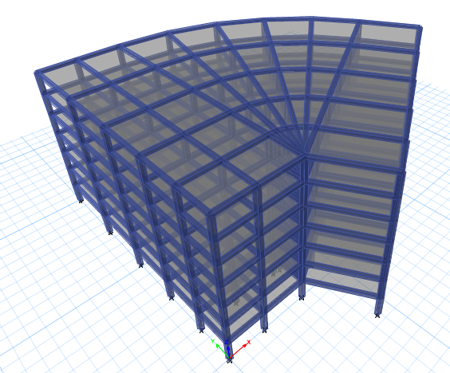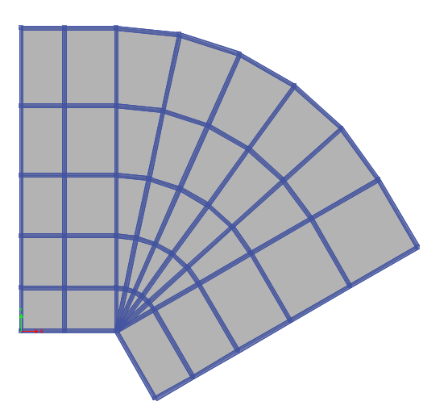

Modelling Approach from code (Type 2)

Modelling Approach from code (Type 3)

